Chapter 9, Problem 54.

In the circuit of Fig. 9.61, find V_{s} if I_{o} = 2∠0° A.

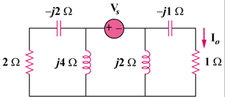

Figure 9.61
For Prob. 9.54.

